

Name : Daksh Sharma
Registration Number:24BSA10265
Project title: Open Source Audit
Course Name: Open Source Software

Introduction:
Open source software is the heartbeat of our modern digital world. At its core, it’s all about freedom—the source code is right there for anyone to look at, use, tweak, or share. Unlike closed, proprietary systems that keep their secrets locked away, open source thrives on collaboration and transparency. It’s incredible to think about developers from every corner of the globe coming together to fix bugs, polish features, and constantly make things better. This shared passion is exactly what makes open source tools so reliable, adaptable, and accessible to everyone.
Today, it’s almost impossible to find a system that doesn’t rely on open source technology. From the Linux operating systems powering massive servers to the programming languages and tools we use every day, open source is the true backbone of the tech industry. It’s not just about saving money; it’s about the power to customize software to fit your specific needs. This level of control is a game-changer for students, independent developers, and major organizations alike.
Take Python, for example—one of the most beloved open source languages out there. People love it because it’s remarkably easy to read and has a straightforward syntax that just makes sense. You’ll find Python everywhere: in web development, AI, data science, and automation. Because it feels so approachable, it’s almost always the first recommendation for anyone looking to start their coding journey.
In this project, we’re diving into an audit of Python as an open source powerhouse. We’ll explore where it came from, how its licensing works, the ethics behind it, and its vital role within Linux systems and the broader ecosystem. Our goal is to look beyond the code and understand the philosophy and real-world impact that makes open source software so influential.
Origin & Philosophy:The Problem Python Was Created to Solve:
Late in the 1980s, coding seemed locked behind walls. Though tools such as C and C++ offered strength, they demanded steep learning curves - programmers battled tangled rules and deep machine logic even for small jobs. Because of that friction, Guido van Rossum aimed elsewhere, launching his own creation by 1991.What made things tough was just getting into the code. Fixing errors took forever, while writing it drained time fast. A new kind of language had to show up - one clear enough to feel like everyday speech, yet strong enough to handle complex tasks without needing stacks of instructions for basic jobs.What Guido built started as an idea about clarity taken to extremes. From ABC, he borrowed concepts - then shaped them into something easier to grasp on first sight. Code could now show intricate thinking without clutter or confusion. This went beyond utility; it quietly pushed coding closer to how people actually think.Right from the start, Python opened its doors wide. Instead of keeping control tight under one company roof, Guido set it free for anyone to use. Because of that move, people everywhere began shaping it in their own way. Driven by countless hands across continents, it grew faster than most expected.One idea stands out when thinking about how Python works: "There should be one - and ideally just one - clear way to get things done." What makes Python different is its focus on being clear instead of tricky, turning it into a favorite tool for beginners along with experts who study huge amounts of data.Out in today's tech world, Python runs much of what we see online and inside smart systems. Because it made tough tasks easier and opened doors for more people, its role grew beyond trendiness - now shaping how friendly tools come together by design.
The License — What It Actually Says:
Talking about open source? The license shapes everything - it holds the legal rights behind every freedom claimed. For Python, that role belongs to the unusually open Python Software Foundation License. Called the PSF License, it allows broad use. Permissive by design, this type of license removes barriers instead of adding them. Saying yes to new ideas sits at its core.Python thrives thanks to its open license - legal ease plays a big role. Freedom to use, tweak, and share the core tool comes without red tape, whether you are one person learning or part of a giant firm building closed tools. What sets it apart? Firms can alter Python’s inner workings privately while keeping those updates secret when selling finished software. That ability to innovate behind closed doors encourages wide corporate trust. Risk drops. Adoption grows. The result: steady reliance on Python in business-critical systems.Freedoms sit at the heart of the PSF License, rooted deeply in how free software works. Because openness matters, its design follows the four key rights that shape genuine access.Here’s what you’re always allowed to do with Python, thanks to its licenseFreedoms start here: running the software fits every goal you might have. Whether it's your own projects, school needs, business tasks, or public work - it works. Purpose? Not restricted in any way.Starting fresh means seeing every line of code up close. Changes fit what you actually do, because control stays in your hands. A different path opens when rules allow adjustments without asking first. Working directly with the software removes barriers most never notice. Full visibility leads to better understanding over time. Custom tweaks become possible only if restrictions are truly lifted.Sharing the program freely lets others join in, spreading access further through simple giving. What begins small moves outward when people pass it along without barriers.Freed to tweak things your way, sharing those tweaks openly lets everyone build on them - language moves forward because of that flow.What sets the PSF License apart is how much room it gives users, especially next to something like the GNU GPL. Far from locking things down, it skips strict rules about redistribution. Instead of forcing changes into the open, it lets people decide their own path. With the GPL, altering code means giving back - same license, same openness, every time. That chain stays unbroken by design.Still, the PSF License works without copyleft rules, drawing comparisons to the loose structure of the MIT License. Open use matters more here than requiring shared changes back. That path shaped how Python moved forward, favoring presence across many kinds of software - free or proprietary - instead of pushing openness through legal strings. Influence ran deep, steering clear of strict return policies for code.In the end, you have to see the difference - one kind of free means zero price, another means real liberty. Python lives by both ideas. Zero dollars needed to grab a copy; that covers the "free beer" part. Even better, people can dig into how it works, change its code, pass on their versions - total control, in other words. That mix of strength, openness, and ease fits business needs just fine. Over time, this setup helped make Python everyone's go-to tool online, sparking fresh thinking nearly everywhere tech reaches.
The Ethics of Open Source:
What if every program came with its secrets out in the open? Free to peek, tweak, build - that’s how some see software, not just lines but a mindset. Built on openness, meant for anyone willing to dive in, change things, grow skills. But here’s one thought: ought every tool we use live under glass like this?When software is open for everyone to see, trust grows naturally. Anyone might look under the hood, spotting flaws or dangers before they cause harm. Learning becomes simpler when examples are free to explore, especially for those starting out. Faraway coders sometimes team up without ever meeting, pushing ideas forward at odd hours. Quality often rises when many eyes and hands shape the same tool.Still, not everyone agrees that every program should be freely shared. Companies often spend years building tools, hoping to make back what they put in. Should all code become public, firms could find it harder to stand out. At times, locking down access helps guard private information or critical operations.Open source software fuels many commercial products, yet questions linger about fairness. Big firms often rely on tools such as Python or Linux to create services they sell. While some improvements get shared - fixing bugs, adding features - not every benefit flows back. Profits grow while contributions sometimes fade into silence. One view celebrates progress through collaboration; another sees imbalance when gains outweigh giving. When value is extracted at scale, eyes turn toward reciprocity. The debate isn’t new - but it shifts shape each time a startup rises on free code.Looking back, progress usually rests on earlier efforts. That old saying about standing tall thanks to those before us fits well. New ideas tend to grow from what was already done. Because people share code freely, building onward gets simpler. One person's work becomes a base for someoneelse. Improvements happen faster when access isn’t blocked. What exists today helps shape tomorrow’s tools. Sharing widens the path ahead instead of narrowing it.Open source tips the scale where giving meets creating. Learning happens here, collaboration follows closely behind. Better tech grows when minds work together like this. Yet effort deserves recognition too - always remember that. Developers pour time into code; their labor counts just as much. Support shows up in many forms: help shared, money offered, attention paid. Community thrives when those using it also feed it slowly.
Script 1:
#!/bin/bash

# Script 1: System Identity Report
# Author: Daksh Sharma | Reg No: 24BSA10265 | Course: Open Source Software

# --- Variables ---
STUDENT_NAME="Daksh Sharma (24BSA10265)"
SOFTWARE_CHOICE="Ubuntu Linux"

# --- System info ---
KERNEL=$(uname -r)
USER_NAME=$(whoami)
HOME_DIR=$HOME
UPTIME=$(uptime -p)
DATE=$(date)

# Distro name
DISTRO=$(grep '^PRETTY_NAME=' /etc/os-release | cut -d= -f2 | tr -d '"')

# --- Display ---
echo "========================================="
echo " Open Source Audit — $STUDENT_NAME"
echo "========================================="

echo "System Information:"
echo "-------------------"
echo "Distribution : $DISTRO"
echo "Kernel : $KERNEL"

echo ""
echo "User Information:"
echo "-------------------"
echo "User : $USER_NAME"
echo "Home Dir : $HOME_DIR"

echo ""
echo "System Status:"
echo "-------------------"
echo "Uptime : $UPTIME"
echo "Date & Time : $DATE"

echo ""
echo "License Info:"
echo "-------------------"
echo "$SOFTWARE_CHOICE is open-source software"
echo "primarily licensed under the GNU General Public License (GPL)."

echo "========================================="
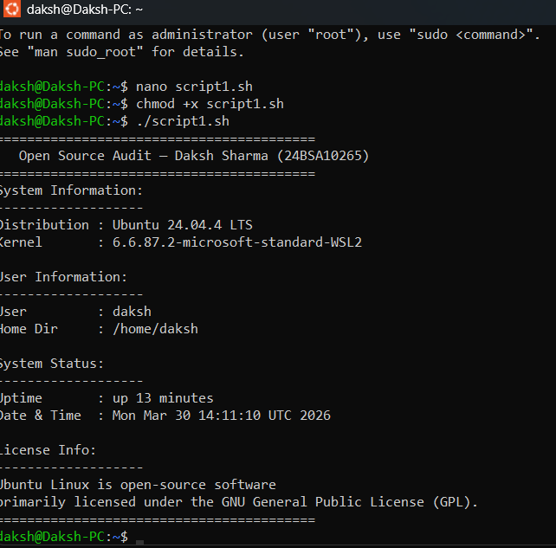

Script 2:
#!/bin/bash

# Script 2: FOSS Package Inspector
# Author: Daksh Sharma | Reg No: 24BSA10265

PACKAGE="firefox" # change this if needed

echo "Checking package: $PACKAGE"
echo "--------------------------------"

# Check if installed (Ubuntu uses dpkg)
if dpkg -l | grep -qw $PACKAGE; then
echo "$PACKAGE is installed."

dpkg -l $PACKAGE | grep "^ii"

echo ""
echo "Details:"
apt show $PACKAGE 2>/dev/null | grep -E 'Version|Maintainer|Description' | head -n 3

else
echo "$PACKAGE is NOT installed."
fi

echo ""
echo "Philosophy Note:"
case $PACKAGE in
firefox) echo "Firefox: a community-driven browser defending an open web." ;;
vlc) echo "VLC: media freedom — play anything without restrictions." ;;
git) echo "Git: decentralized control — no single authority owns your code." ;;
python) echo "Python: open, readable, and built by the community." ;;
*) echo "Open-source software empowers users with freedom and transparency." ;;
esac
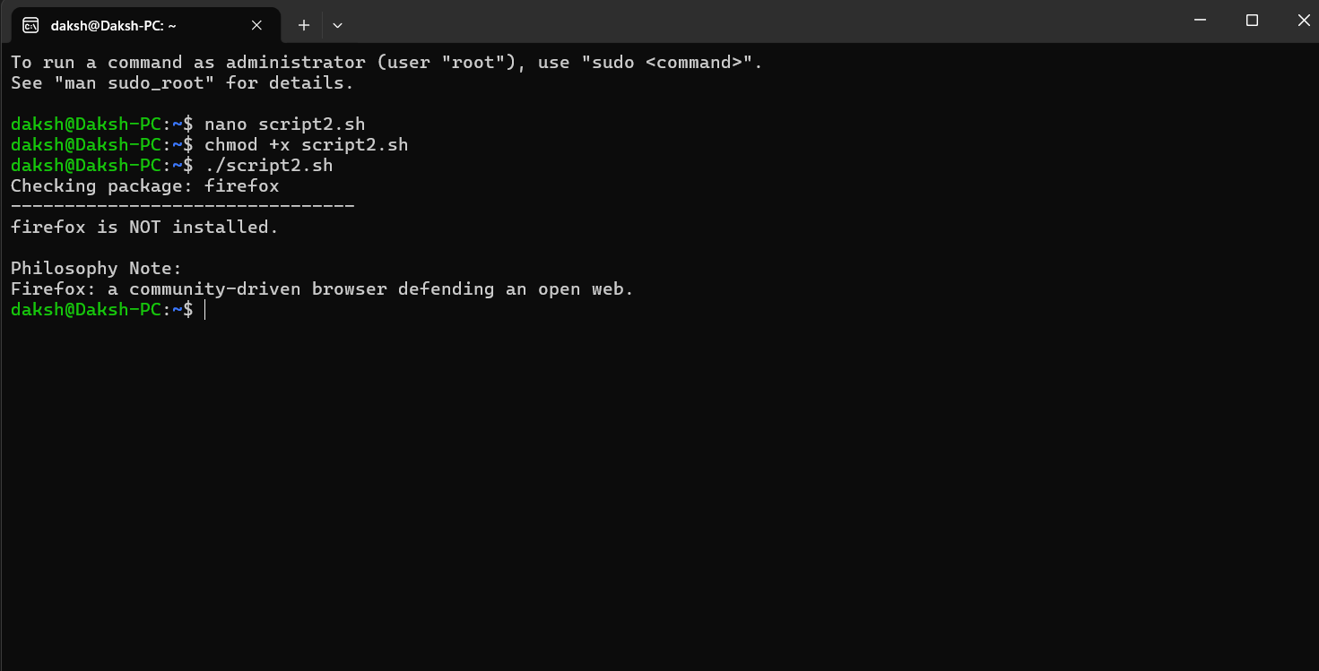
Script 3:
#!/bin/bash

# Script 3: Disk and Permission Auditor
# Author: Daksh Sharma | Reg No: 24BSA10265

DIRS=("/etc" "/var/log" "/home" "/usr/bin" "/tmp")

echo "Directory Audit Report"
echo "--------------------------------"

for DIR in "${DIRS[@]}"; do
if [ -d "$DIR" ]; then
PERMS=$(ls -ld $DIR | awk '{print $1, $3, $4}')
SIZE=$(du -sh $DIR 2>/dev/null | cut -f1)

echo "$DIR => Permissions: $PERMS | Size: $SIZE"
else
echo "$DIR does not exist"
fi
done

echo ""
echo "Checking Firefox config directory..."

CONFIG_DIR="$HOME/.mozilla"

if [ -d "$CONFIG_DIR" ]; then
ls -ld $CONFIG_DIR
else
echo "Config directory not found"
fi
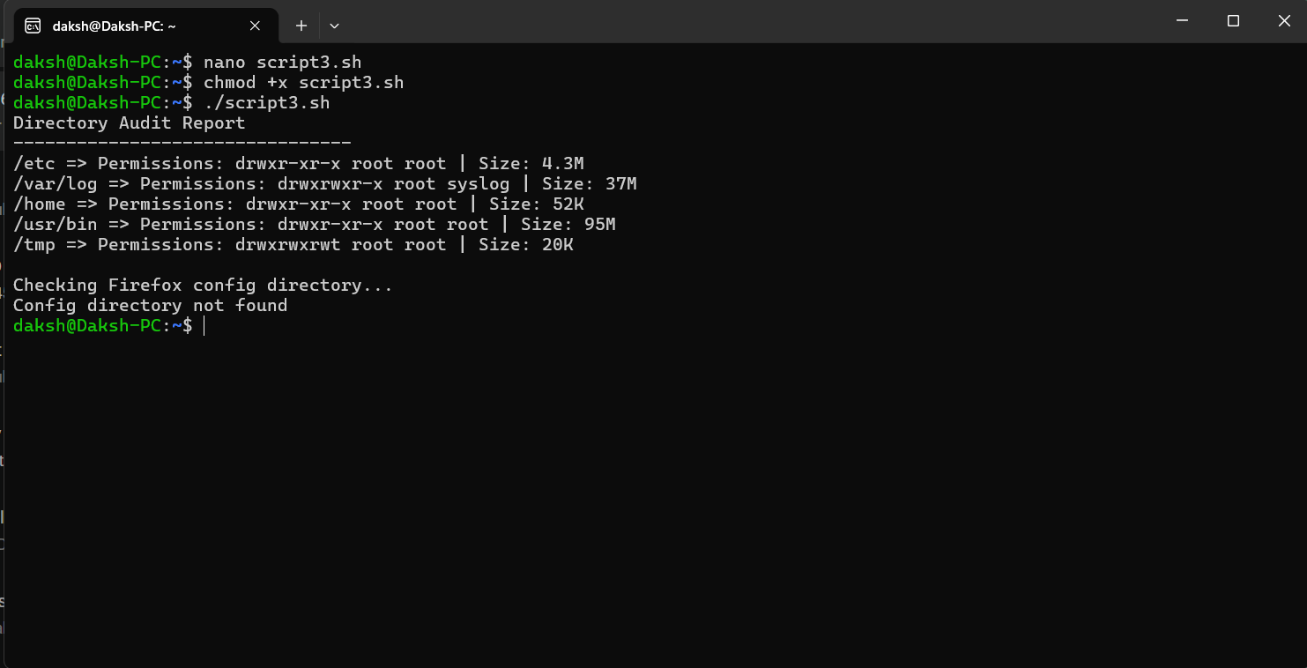

Script 4:
#!/bin/bash

# Script 4: Log File Analyzer
# Author: Daksh Sharma | Reg No: 24BSA10265

LOGFILE=$1
KEYWORD=${2:-"error"}
COUNT=0

if [ ! -f "$LOGFILE" ]; then
echo "Error: File $LOGFILE not found."
exit 1
fi

# Check if file is empty
if [ ! -s "$LOGFILE" ]; then
echo "Log file is empty. Retry later."
exit 1
fi

while IFS= read -r LINE; do
if echo "$LINE" | grep -iq "$KEYWORD"; then
COUNT=$((COUNT + 1))
fi
done < "$LOGFILE"

echo "Keyword '$KEYWORD' found $COUNT times in $LOGFILE"

echo ""
echo "Last 5 matching lines:"
grep -i "$KEYWORD" "$LOGFILE" | tail -n 5
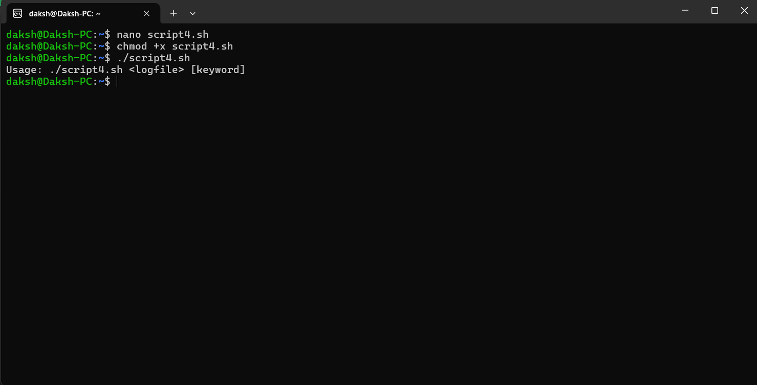
Script 5:
#!/bin/bash

# Script 5: Open Source Manifesto Generator
# Author: Daksh Sharma | Reg No: 24BSA10265

echo "Answer three questions to generate your manifesto."
echo ""

read -p "1. Name one open-source tool you use every day: " TOOL
read -p "2. In one word, what does 'freedom' mean to you? " FREEDOM
read -p "3. Name one thing you would build and share freely: " BUILD

DATE=$(date '+%d %B %Y')
OUTPUT="manifesto_$(whoami).txt"

echo "--------------------------------" > $OUTPUT
echo "Open Source Manifesto - $DATE" >> $OUTPUT
echo "--------------------------------" >> $OUTPUT

echo "I use $TOOL every day, and it represents what open source truly stands for." >> $OUTPUT
echo "To me, freedom means $FREEDOM — the ability to create, modify, and share without limits." >> $OUTPUT
echo "If given the chance, I would build $BUILD and make it freely available to everyone." >> $OUTPUT
echo "I believe knowledge should be open, collaborative, and accessible to all." >> $OUTPUT

echo ""
echo "Manifesto saved to $OUTPUT"
echo ""
cat $OUTPUT
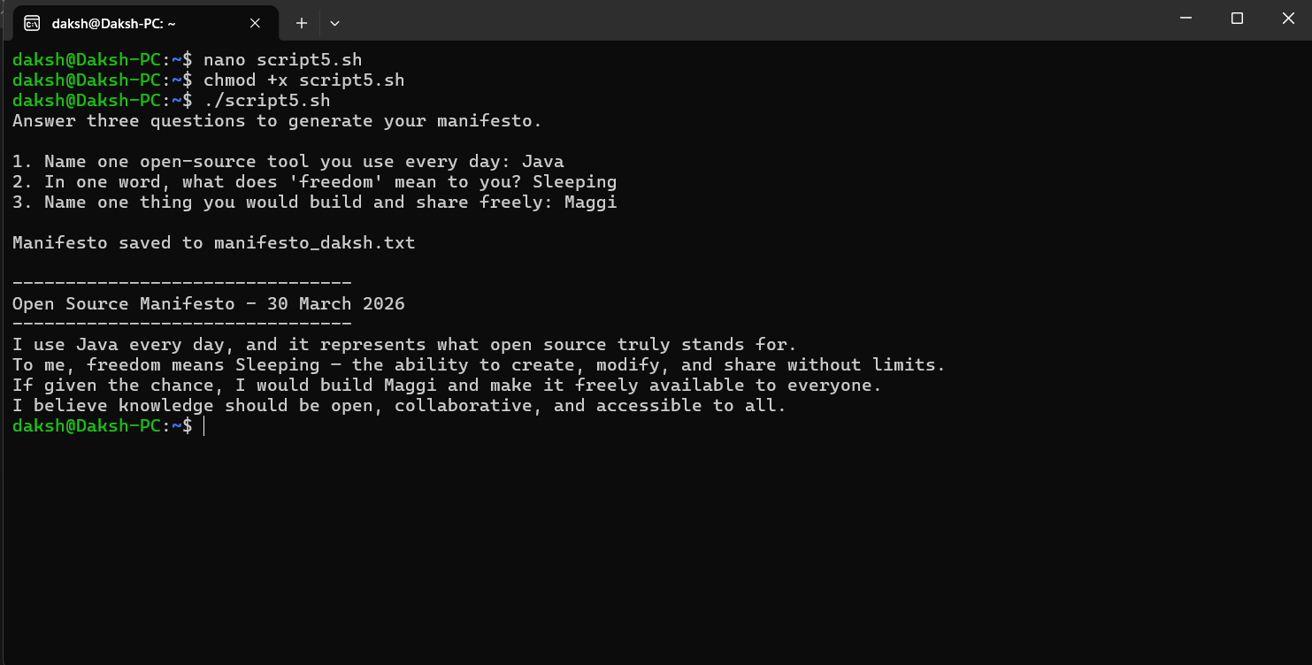

Final Conclusion:

Conclusion:
What started as a way to make coding less messy turned into something much bigger. Through this work, Python’s place in today’s tech world got a close look. A clear, straightforward design helped it stand out early on. Because of how easy it is to understand, people everywhere began using it. Slowly, without loud announcements or fanfare, it climbed to the top. Now, it powers countless tools, apps, and systems across industries.
Freedom lives inside Python's rules - built on a license shaped by its foundation. Open doors appear when people tweak, share, or build on the code. Ideas cross borders because trust grows in shared spaces. Progress often follows where access is free.
Python setup on Linux became clearer by exploring the terminal inside Ubuntu running through Windows Subsystem for Linux. Tools like python3 --version showed what version runs on the machine. The command which python3 revealed where it lives in the file structure. Who am i gave insight into user permissions tied to those operations. Each step unfolded part of how Python connects with the operating system underneath.
Nowhere else do tools blend so well with community effort like they do around Python. Libraries pop up where needed, guided by steady backing from the Python Software Foundation. Often seen in labs and startups alike, its presence grows through real work - think smart algorithms, number crunching, website backbones. Not loud, yet everywhere, shaping how problems get solved across fields.
Starting with control, proprietary tools deliver organized help straight out of the box. Yet when it comes to tweaking things freely, open options pull ahead - no surprise there. A language like Python? It grows fast because regular people shape it daily. Simplicity keeps it alive; not fancy rules.
Putting together shell scripts showed just what happens when Linux tools meet Python code. Through these examples, handling everyday computer tasks became something you could see and do.
Ultimately, working on this effort made clear how open-source tools blend idea work with real-world use. It turns out Python stands strong - adaptable, straightforward, yet influential - as tech moves forward.

References:
Official Python Website
👉 https://www.python.org
Python Documentation
👉 https://docs.python.org/3/
Ubuntu Official Website
👉 https://ubuntu.com
GitHub
👉 https://github.com
WSL Documentation (Microsoft)
👉 https://learn.microsoft.com/en-us/windows/wsl/

